

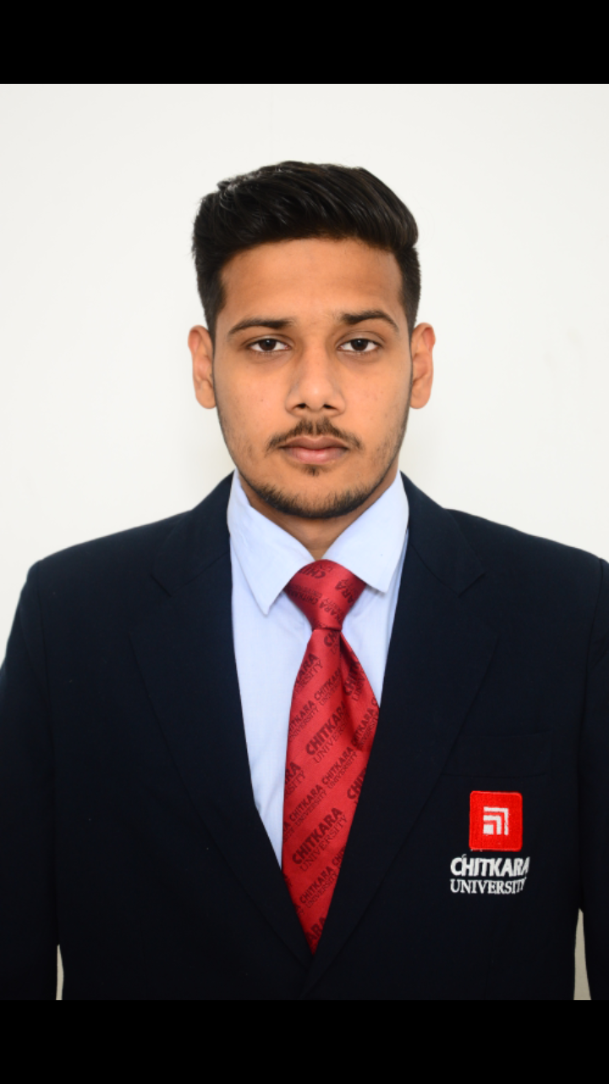

Rajinder Singh

#B1/1272,Near Khera,

Old Rajpura

+91-8699416999

singh.vicky5001@gmail.com

**EDUCATION** **:**

|  |  |  |  |
| --- | --- | --- | --- |
| **Qualification/Degree** | **School/College** | **University or Board** | **Year** |
| B. E. (CSE) | Chitkara School Of Engg. & Tech., Punjab | Chitkara University | 2014-2018 |
| Class XII | Mukat Public School | C.B.S.E | 2013-2014 |
| Class X | Public Modern Senior Secondary School | P.S.E.B | 2011-2012 |

**PROJECTS & TRAININGS:**

* **Library Management system (January 2016 - May 2016)**

A software to provide friendly interface for librarians and students to keep track of library account details. Technologies Used: C++ along with Graphics.

* **Super Sensitive Intruder Alarm (January 2015 - May 2015)**

This circuit is designed to alert the user when an intruder enters into the home. If there is any obstacle in front of IR sensor, it generates an interrupt signal.

* **Ola Cabs System (July 2016 - December 2016)**

This system could get the information about the ola cabs available at a given location, ride availiability, ride estimate, cost estimate. Documentation of this system using extreme programming model was done.

* **Underwent 1 month summer training (June 2015-July 2015)**

Programming in scratch , a certificated edx course. Has been done and a game has been made.

**ACHIEVEMENTS:**

**Academic**

* Scored 80% in 10th class and an award of appreciation for the same..
* Secured 1st position in Math's quiz in X

**PROFESSIONAL SKILLS:**

* **Languages:** C, C++, HTML, CSS
* **DBMS:** My SQL, Pl/Sql.
* **Application Software:** Multisim, Cisco Packet Tracer

**CO-CURRICULAR ACTIVITIES:**

* Volunteered for organizing Orientation Program for 2015 batch.
* Participated in blood donation camp organized by Red Cross Society at Chitkara University on National Blood Donation day in 2014.
* Participated in the workshop organized on Green Building at Chitkara University in 2014.
* An active participant, winner and organizer in various events like technical, sports, cultural at school level
* An active participant in cricket matches.

**(Rajinder Singh)**